JOIN Statements

**Join** **Overview**

* We can use the JOIN operator to combine rows from two or more tables.
* The tables being joined are related by a common column, which is usually the primary key of one table, and appears as a foreign key in the other table.
* There are two types of joins; inner joins and outer joins.

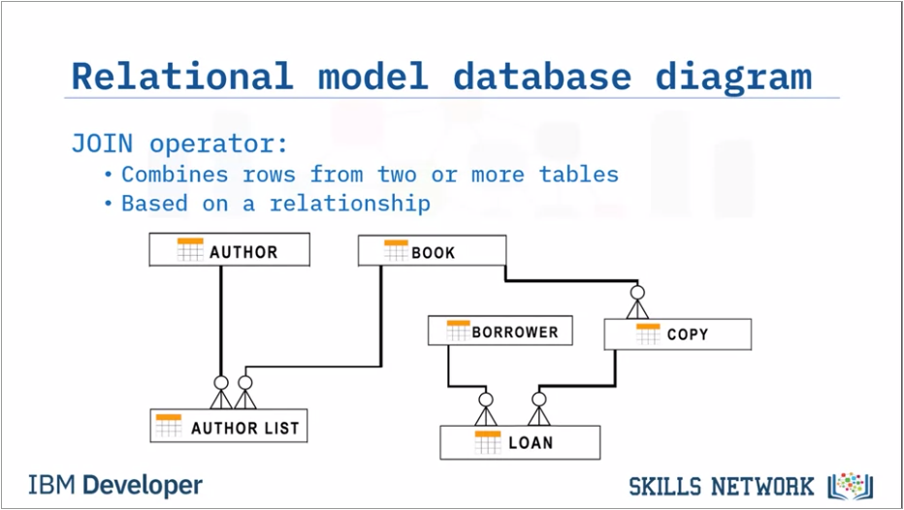

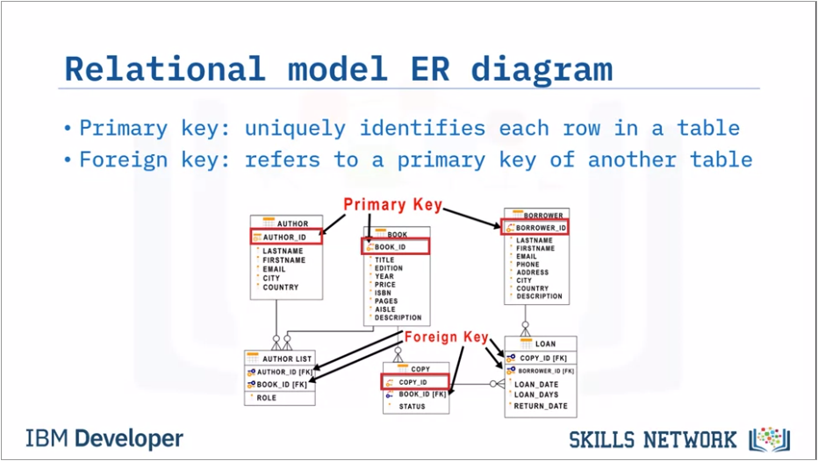

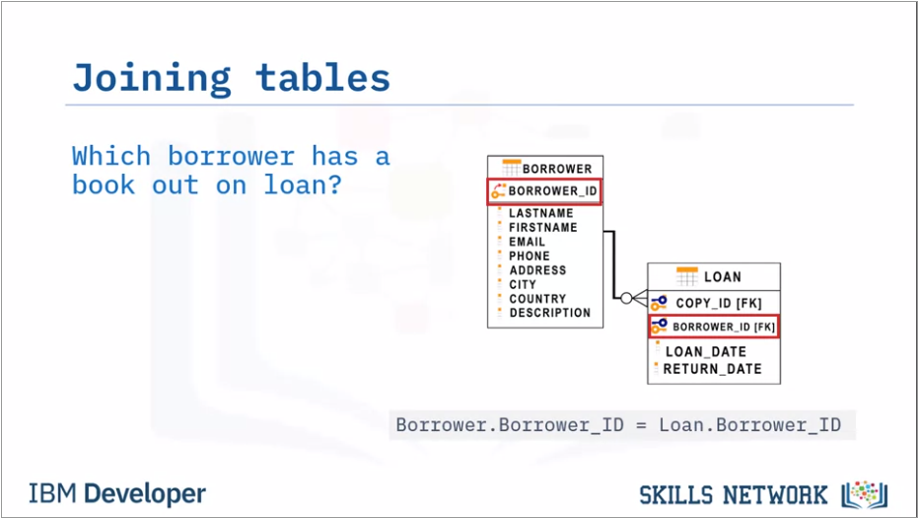

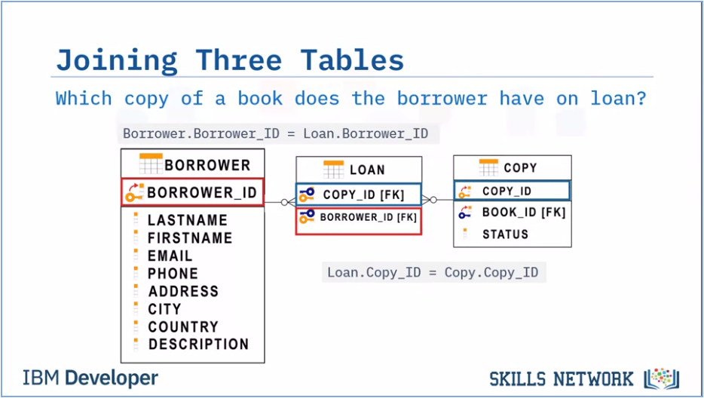

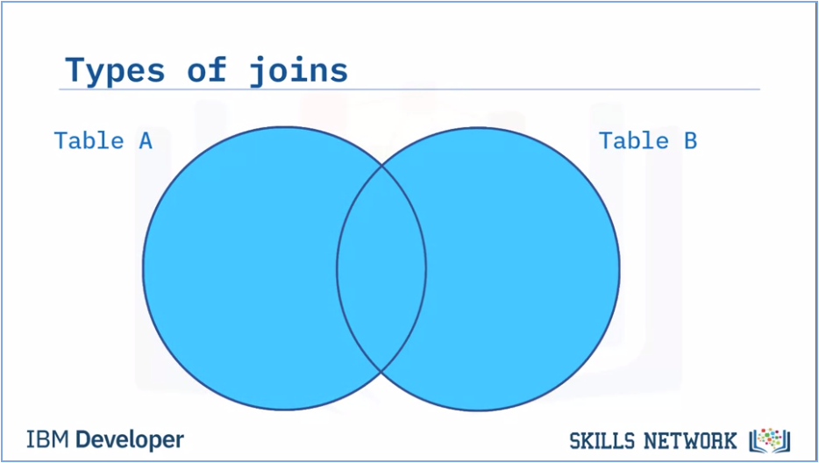



**Inner Join**

* Inner joins return only the rows from the tables that have matching value in a common column, usually the primary key of one table that exists as a foreign key in the second table.
* Rows from joined tables that do not have a matching value do not appear in the result.

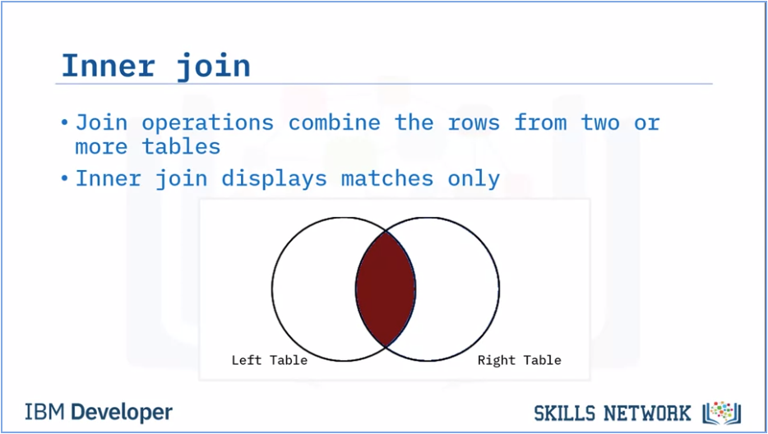

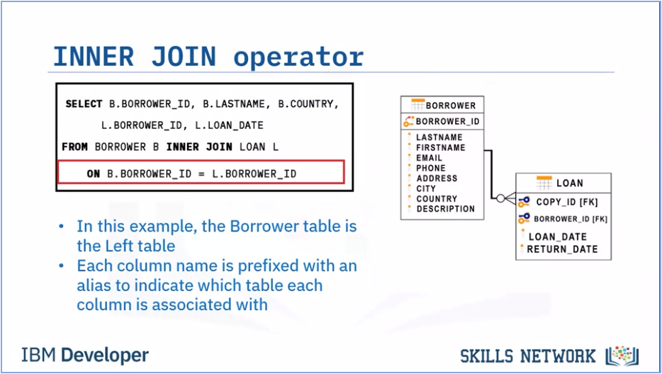

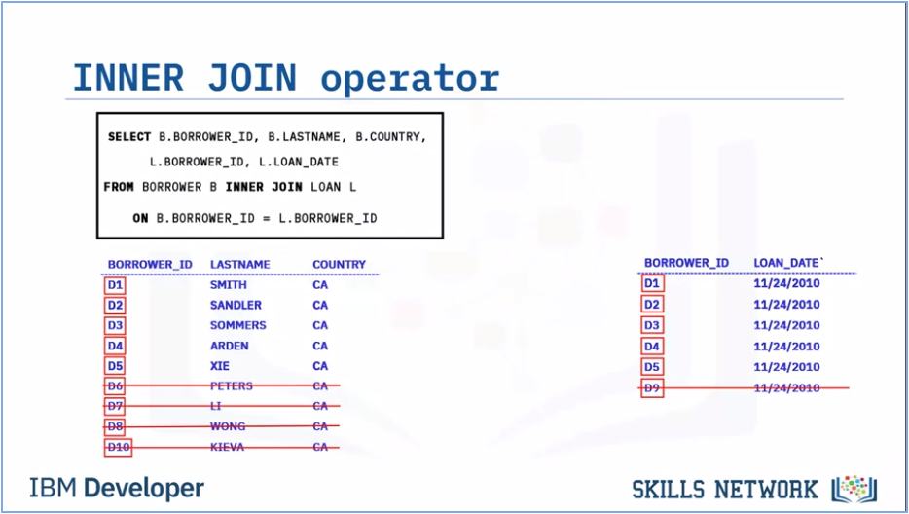

* The result set shows only the rows from both tables that have the same borrower ID.
* Rows with Borrower_IDs that do not match are not displayed.
* The Borrower_Id, Lastname, and Country columns are taken from the Borrower table and joined to the Borrower_Id and Loan_Date columns from the Loan table.

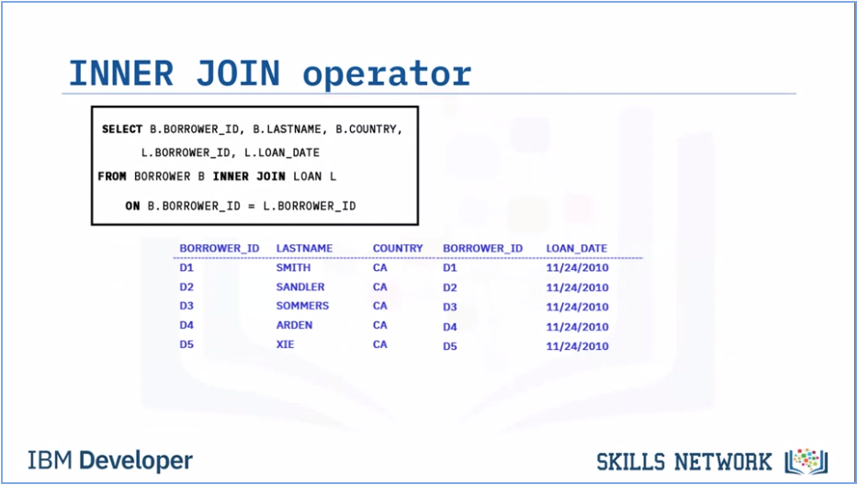

* The rows are displayed if they Borrower_Id matches.

**Outer Joins**

* There are many varieties of outer join that we can use to refine our result set. Left outer joins return all rows from the left table, and all the rows form the right table that match that an inner join would return and all the rows in the first table that do not have a match in the second table.
* Right outer joins return all the rows that an inner join would return and all the rows in the second table that do not have a match in the first table.
* Full outer joins return all matching rows from both tables and all the rows from both tables that don’t have a match.

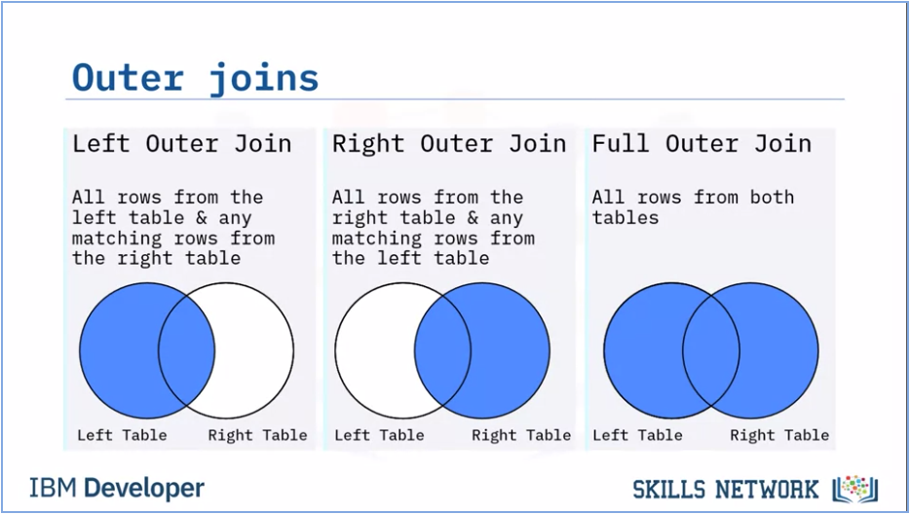

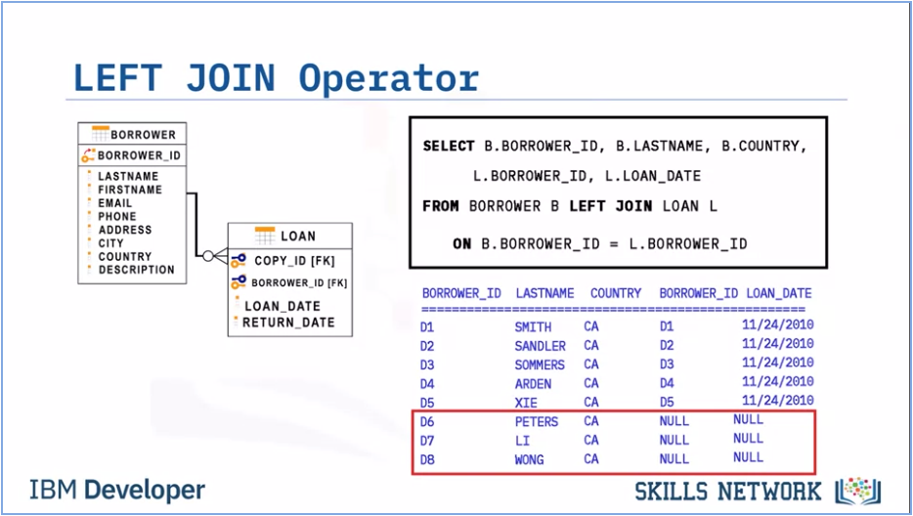

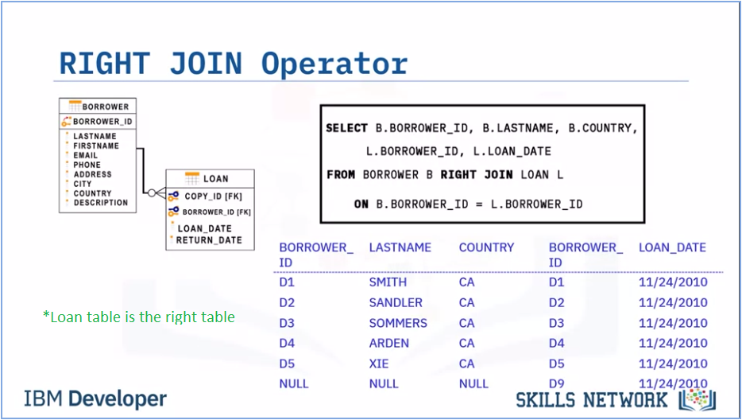

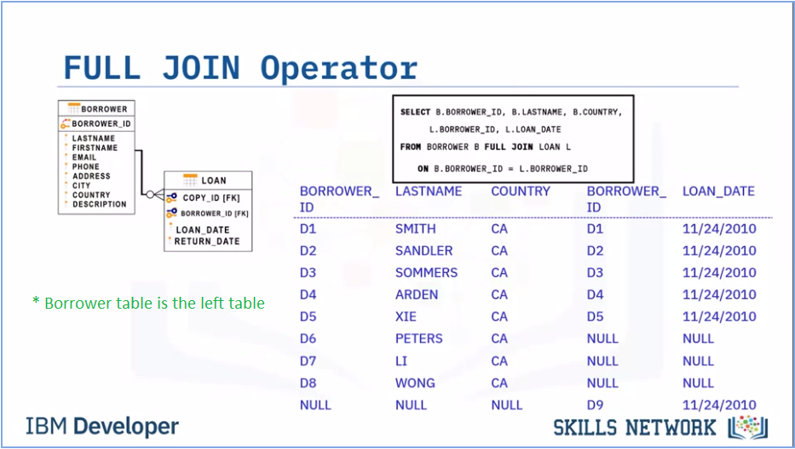

**Summary & Highlights**

* A join combines the rows from two or more tables based on a relationship between certain columns in these tables.
* To combine data from three or more different tables, we simply add new joins to the SQL statement.
* There are two types of table joins: inner join and outer join; and three types of outer joins: left outer join, right outer join, and full outer join.
* The most common type of join is the inner join, which matches the results from two tables and returns only the rows that match.
* We can use an alias as shorthand for a table or column name.
* We can use a self-join to compare rows within the same table.